

**CAPSTONE PROJECT SYNOPSIS FORMAT ACY: 2022-23**

|  |  |
| --- | --- |
|  | Proposed Project Title:  Design of automatized disease detection and fertilization system for agricultural crops |
|  | Project ID:  SVCE/2019-23/PROJ/116 |
|  | Program(s):  Computer Science and Engineering |
|  | **Name(s) of project guide(s):**   1. Name: Prof. / Dr. / Mr. / Mrs: Dr.Poornima G R   Email id: poornima.gr_ece@svcengg.in  Contact No.: 98867 53829   1. Name: Prof. / Dr. / Mr. / Mrs.: Prof. Niranjana C   Email id: niranjana.c_ece@svcengg.in  Contact No.: 88706 45085 |
|  | **Name of Team Members:**   |  |  | | --- | --- | | Name:Neethushree.K USN No.: 1VE19EC070  Email id: neethugowda1201@gmail.com  Mobile No: 9632726075 | Name: Priyanka B H  USN No.: 1VE19EC082  Email id: priyanka200203@gmail.com  Mobile No.: 7349283003 | | Name: Harsha B A  USN No.: 1VE19CS054  Emailid: harshamonishagowda@gmail.com  Mobile No.: 86604 80220 | Name: Harish Thanikaivelu  USN No.: 1VE19CS052  Email id: jimharish@gmail.com  Mobile No.: 9742572197 | |

**Title:**

Design of automatized disease detection and fertilization system for agricultural crops.

**Introduction:**

India has a vast variety of climatic conditions and crops these days are all hybrid in nature hence to support during the climatic changes every day there is a huge challenge for the farmers and when doing so there is certainly similar kind of diseases or deficiency problems developed in the crops this can sometimes be fatal for the crops.

The project aims to be personalized care given to the crops based on the problems arising in the crops and provide proper fertigation for the crops to survive and produce good yields.

**Fertigation:**

Fertigation is a method of fertilizer application in which fertilizer is incorporated within the irrigation water by the drip system. In this system, fertilizer solution is distributed evenly in irrigation. The availability of nutrients is very high therefore the efficiency is more. In this method, liquid fertilizers, as well as water-soluble fertilizers, are used. By this method, fertilizer use efficiency is increased from 80 to 90 percent.

**What is Smart Farming?**

Smart farming or Smart Agriculture system is the term used to describe the adoption of modern information and communications technologies to enhance, monitor, automate, or improve agricultural operations and processes.

**Factors causing plant diseases:**

Pathogens are the main reason for causing diseases in the plant. There is a department named after it called plant pathology which mainly deals with the study of the pathogen. Two main factors cause disease in plants and they are pathogens and environmental conditions.

The microbes favoring plant diseases are enumerated below:

* Viral
* Fungi
* Bacteria

**Literature survey:**

Monirul Islam Pavel et al., proposed “An IoT-based plant health monitoring system” in the year 2019, which uses the IoT techniques to monitor and automate farming and monitor the health of crops. This system explains the detailed methodology to monitor plant health. But it is just information-oriented literature, the practical approaches to monitoring health are not present [1].

Jayant Devare, Neha Hajare., proposed “A Survey on IoT-Based Agricultural Crop Growth Monitoring and Quality Control.” In the year 2019, Which uses IoT techniques to monitor and maintain quality at the same time for crop farming. This system also measures the quality of vegetation but the practical usage techniques are not involved [2].

T.Rajeshwari et al., proposed “Smart Agriculture Implementation using IoT and Leaf Disease Detection using Logistic Regression” in the year 2021, which uses the methods to detect the diseases in the crops by scanning the leaves using the logistic regression method. This model includes the plant monitoring tests along with disease detection but relies on single model for training the AI model which is logistic regression [3].

Folasade Olubusola Isinkaye, Emmanuel Damilola Erute., proposed “Automated agriculture based on ML Algorithms.” In the year 2022, Here the treatment is recommended in the ML algorithms based on the disease detected but it is not integrated with the IoT module to provide treatment to the crops [4].

In general, the pros and cons of all the literature referred to are given below,

**Pros:** The above systems have proven successful and straightforward and simple systems.

**Cons:** Even if it is having proven successful it is not reliable in long run, also being straightforward is necessary but precise agriculture is not possible in just one module, and is one-dimensional in either disease prediction or fertilizer spraying.

**Problem Formulation/Objectives:**

Problem:

Crops these days are prone to various diseases and these diseases can sometimes be fatal for the crops also climatic conditions play a major role in the well-being of the crops.

Solution:

Develop an AI-based system to decode the diseases the crops are affected with based on scanning the leaves and analyzing what could be the possible fertilizer that could be given to the crop to cure the crop from the disease.

Objectives:

* To increase the yields.

This is done by monitoring the growth and soil conditions with time to time and treating the crops with utmost precision, this helps in better yields.

* To provide a precise amount of fertigation to the crops.

When the soil conditions and weather conditions are observed then we can supply precise amount of fertigation to the crops.

* To analyze the disease-prone crops and treat them with precise fertilizers and pesticides.

The image is acquired and based on the captured image the disease in the crops is detected and based on the disease that is been detected the system supplies with fertilisers and treat the crops.

* To have quality products from the crops.

Since the method used is precise the quality of the crops is preserved with a more cost efficient way.

**Proposed Methodology:**

Proposed to develop two modules namely:

AI module: This module is responsible for disease prediction in the crops by scanning the leaves.

IoT Module: This module is responsible for the fertigation of the crops based on the data provided by the AI module. These two modules must be integrated and coordinated to be used.

**AI Module follows any one of the below methods to predict the diseases in crops:**

Supervised learning method.

Unsupervised learning method.

Semi-supervised learning method.

Reinforcement learning method.

**IoT module includes:**

**Units in IoT module are enumerated below:**

1. Capturing Temperature and Humidity.(DHT22 sensors monitor the temperature and humidity of air)
2. Capturing soil moisture humidity.( YL-69 sensor and LM393 Comparator captures the soil humidity).
3. Solenoid Valve.
4. Fertilizer tank. (tanks containing Nitrogen, phosphorus and potassium fertilizers)

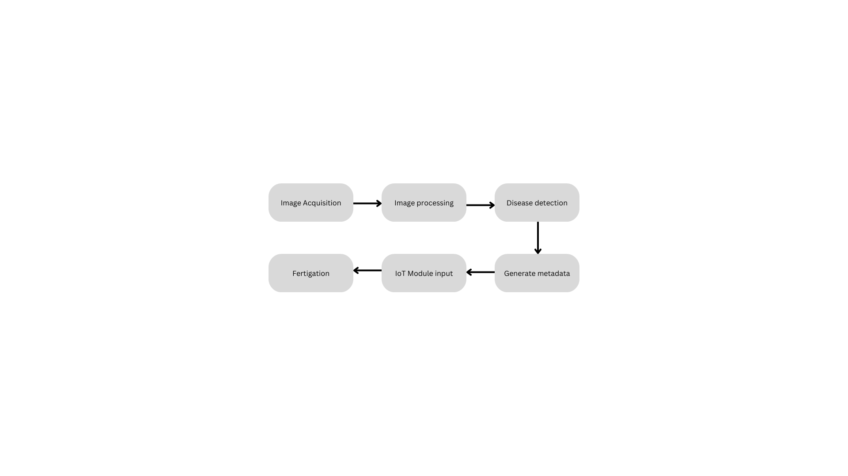The General Workflow of the AI Module and IoT is given in the following Fig.1.1:

**Figure 1.1: Proposed Block Diagram**

The following are the processes undergoing in each stage of the system:

**Image Acquisition:**  The image of the crop leaves is acquired either by employing an automated ESP32 Cam module or also provided with a manual option to override the automation in case of the farmer's choice.

**Image processing:** The image acquired is processed and in this stage, the image acquired is generally segmented part by part and the possible diseases are matched.

**Disease Detection:** The most matching disease that is closest to the leaf condition or the plant condition, in general, is detected in this step.

**Generate Metadata:** The disease detected and the approximate amount of fertilizers that are to be given to the crops to treat the crops are produced as metadata which is the input for the IoT Module.

**IoT Module Input:** This Stage marks the start of the IoT module controls, from here the IoT Module takes the metadata input and with the soil condition being monitored it decides the right amount of fertigation that is to be given to the vegetation.

**Fertigation:** The final step in the system where the fertilizer is mixed with the water and supplied to the crops employing automated workflow.

This process continues each time with just a click of a button thus reducing the time spent by the farmers and increasing the precision in farming leading to better yields that are of high quality.

**Facilities/Equipment Required:**

* Raspberry pi Pico microcontroller
* BC 547
* TP 7805 Transistor
* Solenoid valve for flow control
* DC voltage Booster
* zero PCB
* Resistors
* Soldering station
* 3D Printer
* Miscellaneous Items
* Soil Humidity and moisture sensor

**Expected Outcomes:**

PCO1: Provide proper treatments for unhealthy crops and Maximise yields.

PCO2: Improve the quality of production and reduce the unwanted surplus use of fertilizers and pesticides.

PCO3: Reduce soil pollution.

PCO4: To identify plant diseases using a machine learning algorithm. After the disease is identified, identify the suitable pest for that disease.

**Bibliography/References:**

[1] F. Ahmed, H. A. Al-Mamun, A. S. M. H. Bari, E. Hossain, and P. Kwan, “Classification of crops and weeds from digital images: A support Vector Machine Approach,” *Crop Protection*, vol. 40, pp. 98–104, 2012.

[2] H. Asadollahi, M. S. Kamarposhty, and M. M. Teymoori, “Classification and evaluation of Tomato images using several classifier,” *2009 International Association of Computer Science and Information Technology - Spring Conference*, 2009.

[3] D. Ashourloo, H. Aghighi, A. A. Matkan, M. R. Mobasheri, and A. M. Rad, “An investigation into machine learning regression techniques for the leaf rust disease detection using hyperspectral measurement,” *IEEE Journal of Selected Topics in Applied Earth Observations and Remote Sensing*, vol. 9, no. 9, pp. 4344–4351, 2016.

[4] S. R. Dubey and A. S. Jalal, “Adapted approach for fruit disease identification using images,” *Image Processing*, pp. 1395–1409.

[5] A. Camargo and J. S. Smith, “Image pattern classification for the identification of disease causing agents in plants,” *Computers and Electronics in Agriculture*, vol. 66, no. 2, pp. 121–125, 2009.

[6] M. Islam, Anh Dinh, K. Wahid, and P. Bhowmik, “Detection of potato diseases using image segmentation and multiclass support vector machine,” *2017 IEEE 30th Canadian Conference on Electrical and Computer Engineering (CCECE)*, 2017.

[7] Monirul Islam, Syed Mohammad Kamruzzaman, and Sadman Sakib Hasan, “An IoT based plant health monitoring system,” *International Journal of Recent Trends in Engineering and Research*, vol. 3, no. 2, pp. 252–257, 2019.

[8] Y. Lu, S. Yi, N. Zeng, Y. Liu, and Y. Zhang, “Identification of rice diseases using deep convolutional neural networks,” *Neurocomputing*, vol. 267, pp. 378–384, 2017.

[9] J. Devare and N. Hajare, “A survey on IOT based agricultural crop growth monitoring and quality control,” *2019 International Conference on Communication and Electronics Systems (ICCES)*, 2019.

[10] T. Rajeshwari, P. A. Harsha Vardhini, K. Manoj Kumar Reddy, K. K. Priya, and K. Sreeja, “Smart agriculture implementation using IOT and leaf disease detection using logistic regression,” *2021 4th International Conference on Recent Developments in Control, Automation & Power Engineering (RDCAPE)*, 2021.

[11] S. V, S. R, and S. R, “Fertilizers usage in agriculture and crop prediction using ML Techniques,” *Machine Learning Algorithms for Intelligent Data Analytics*, 2022.

**Proposed work broader area mapping with POs and PSOs:**

* There is a huge increase in the yields and this benefits the overall growth in the GDP contributed by the agricultural share in the country.
* There is quality produce which means there is very less wastage due to bad goods and this can support the surplus needs of the population.
* Precise amounts of fertilizers when given to the crops there is no chance of soil pollution due to the excessive amounts of use of fertilizers.

The Mapping for the Project Outcomes(PO) and Project Specific Outcomes(PSO) is given below:

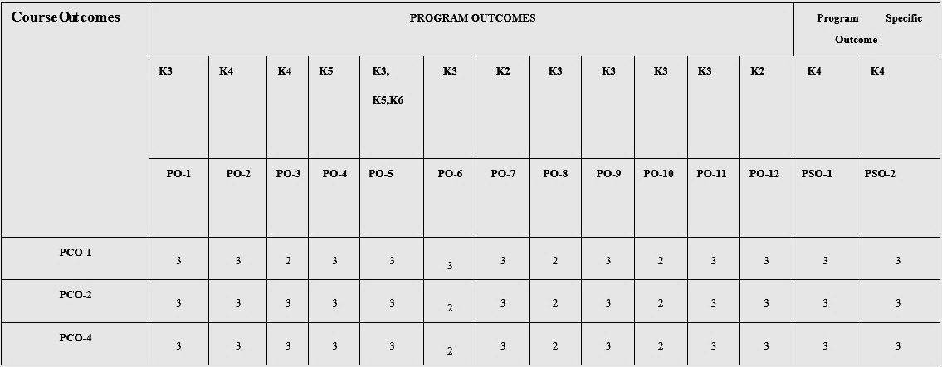

Legend:

K1: Knowledge Level 1

PO-1 Project Outcome 1

(**Engineering Knowledge**: Apply the knowledge of mathematics, science, engineering fundamentals, and an engineering specialization to the solution of complex engineering problems.)

PO-2 Project Outcome 2

(**Problem Analysis**: Identify, formulate, research literature, and analyze complex engineering problems reaching substantiated conclusions using first principles of mathematics, natural sciences, and engineering sciences.)

PO-3 Project Outcome 3

(**Design/development of Solutions**: Design solutions for complex engineering problems and design system components or processes that meet t h e specified needs with appropriate consideration for public health and safety, and cultural, societal, and environmental considerations.)

PO-4 Project Outcome 4

(**Conduct Investigations of Complex Problems**: Use research-based knowledge and research methods including design of experiments, analysis and interpretation of data, and synthesis of the information to provide valid conclusions.)

PO-5 Project Outcome 5

(**Modern Tool usage**: Create, select, and apply appropriate techniques, resources, and modern engineering and IT tools including prediction and modeling to complex engineering activities with an understanding of the limitations.)

PO-6 Project Outcome 6

(**The Engineer and Society**: Apply reasoning informed by the contextual knowledge to assess societal, health, safety, legal and cultural issues and the consequent responsibilities relevant to the professional engineering practice.)

PO-7 Project Outcome 7

(**Environment and Sustainability**:

Understand the impact of professional engineering solutions in societal and environmental contexts, and demonstrate the knowledge of, and need for sustainable development.)

PO-8 Project Outcome 8

(**Ethics**: Apply ethical principles and commit to professional ethics and responsibilities and norms of the engineering practice.)

PO-9 Project Outcome 9

(**Individual and Team Work**: Function effectively as an individual, and as a member or leader in diverse teams, and in multidisciplinary settings.)

PO-10 Project Outcome 10

(**Communication**: Communicate effectively on complex engineering activities with the engineering community and with society at large, such as being able to comprehend and write effective reports and design documentation, make effective presentations, and give and receive clear instructions.)

PO-11 Project Outcome 11

(**Project Management and Finance**: Demonstrate knowledge and understanding of the engineering and management principles and apply these to one’s work, as a member and leader in a team, to manage projects and in multidisciplinary environments.)

PO-12 Project Outcome 12

(**Life-long Learning**: Recognize the need for, and have the preparation and ability to engage in independent and life-long learning in the broadest context of technological change.)

PSO -1 Project Specific Outcome 1(CSE)

**Quick Adaptability**

PSO-2 Project Specific Outcome 2(CSE)

**Envision**

PSO-1 Project Specific Outcome 1(ECE)

**Ability to learn and implement the new technologies in Electronics**

**and Communication domain**.

PSO-2 Project Specific Outcome 2(ECE)

**Ability to Design and manufacture simple and complex Electronic**

**Circuit boards for various applications.**